**DOCUMENTS FOR:**

**1,2 AND 3 (AGREEMENTS FOR SALE)**

**Introduction**

The LSK conditions for sale 2015 state that when a valid sale agreement has been prepared and executed, the step that follows is Completion (Condition 7). The sale agreement is merely executory and it gives no interest. It will only give you an interest when you are able to complete as the purchaser (Specific performance) and vendor (forfeiture).

***Openda v Khan –*** A sale agreement creates no interest over the property.

For completion to take place the purchaser is to deliver the purchase price and the vendor is to deliver the completion documents.

Completion documents mean the deeds and other documents that are necessary for the transfer of good title and as may be defined in the Agreement.

**Agreement 1**

The following are the completion documents which will be required to complete the agreement for sale of agricultural land entered into between Sasha Banks (The “Vendor”) and Christopher Kamende (The “Purchaser”)

* Original title document for the property;
* Copies of the Vendor’s P.I.N. certificate and National Identity Card
* 3 coloured passport size photographs of the Vendor;
* Rent clearance certificate, if any;
* Rates clearance certificate, if any;
* Land Control Board Consent to Transfer;
* Spousal Consent

**Original title document for the property**

A land title document proves ownership and legal right over a piece of land. It is the most fundamental document required during a land transaction and its details are usually changed from the vendor to the purchaser after a land transaction has taken place to show the transfer of ownership.

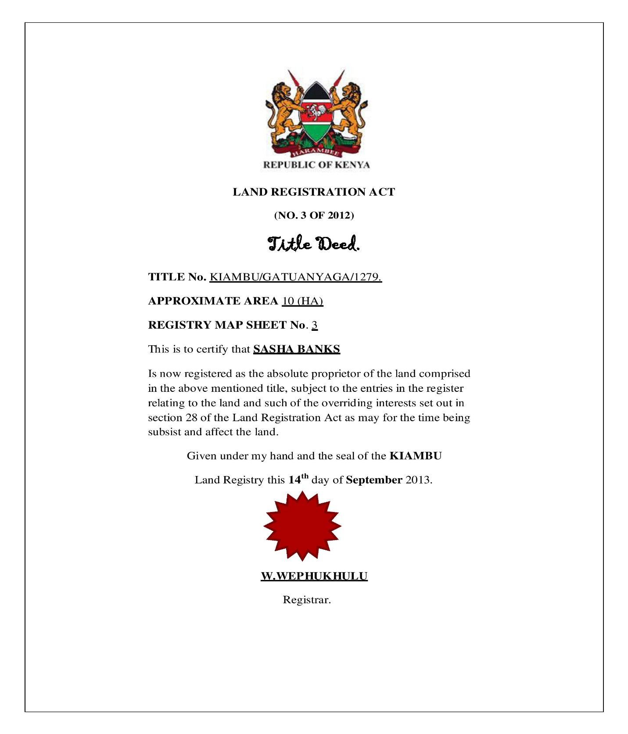

**Rates Clearance Certificate**

Rates are levies payable to the Government through the local authorities under the Rating Act. It certifies that all monies payable to the local authority in respect of that property have been paid. Such monies include:

1. Land rates
2. Interest charges on rates

Sections 38 of LRA require that prior to the Registrar accepting any document intended to transfer or vest any interest in land for registration, there must be also produced a valid RCC.

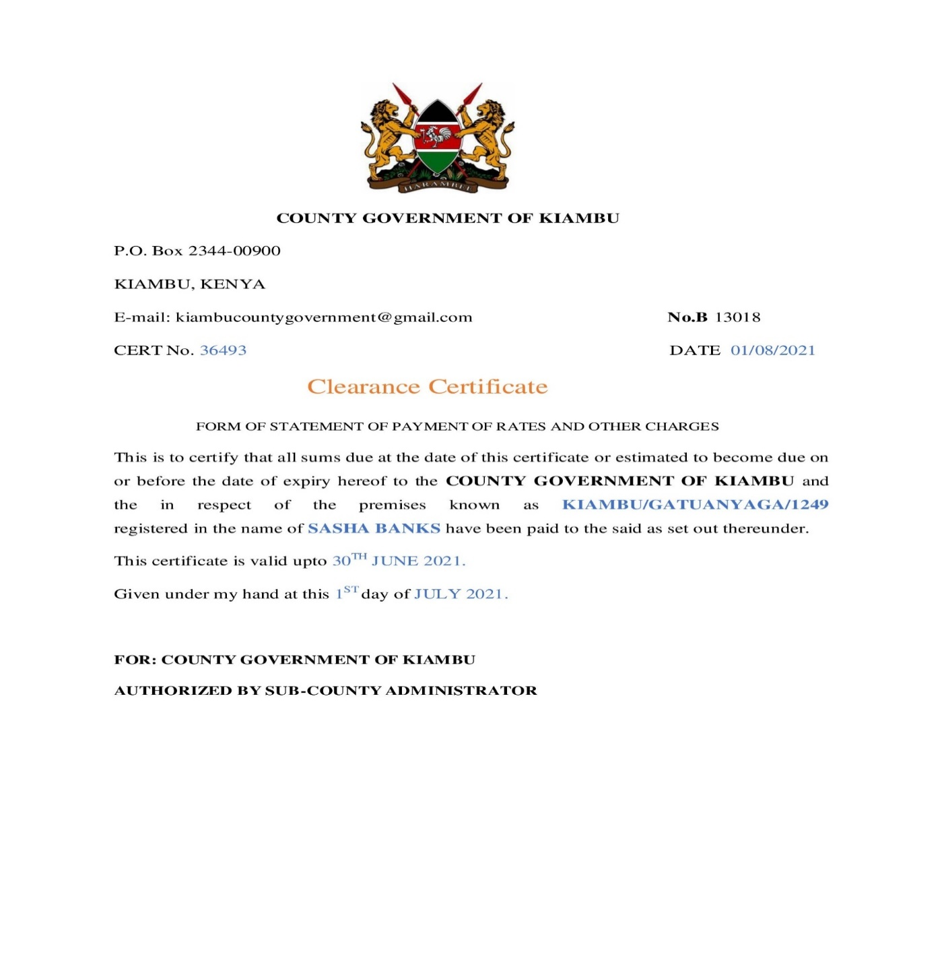

**Land Control Board Consent**

This applies to all property situate within agricultural districts. These are defined in s.2 of the Land Control Act as “any land not within a township or municipality or within Nairobi that is declared to be agricultural land.” Any transaction in respect of agricultural land must obtain the consent of the LCB. This requirement is set out in s.6 of LCA.

*Mucheru v Mucheru [2002] 2 EA 456* -The CA held that if LCB consent is not obtained the transaction becomes void even if the duty to obtain the consent was not exercised.

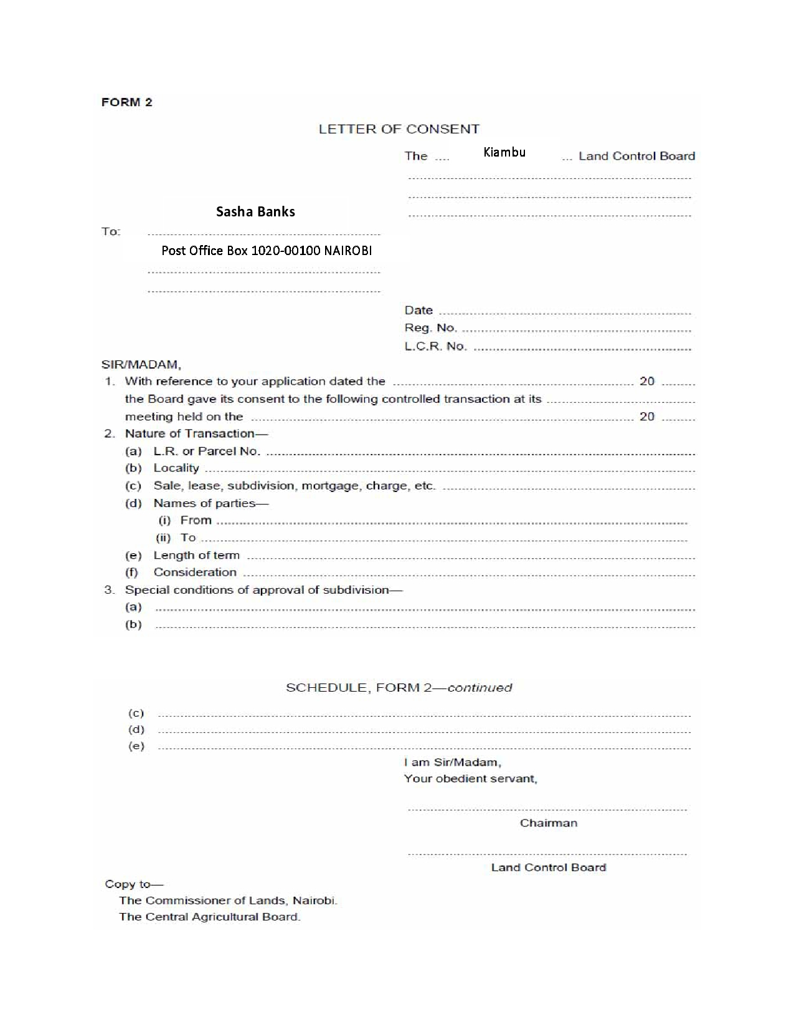

**Copy of the Vendor’s KRA P.I.N. Certificate**

A PIN is a Personal Identification Number used while doing business with Kenya Revenue Authority, other Government agencies and service providers. The law requires that you have a KRA PIN while making some transactions. These include; buying and selling land, importing goods, registering a business.

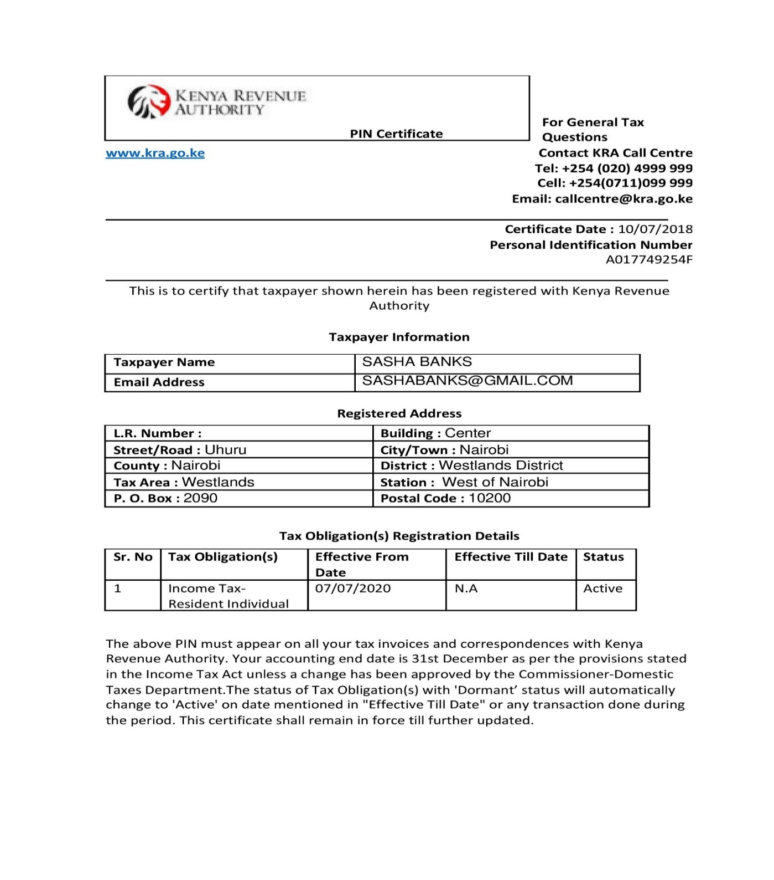

**Copy of the Vendor’s National Identity Card**



**236678963**

**24005414**

**SASHA BANKS**

**KIAMBU**

**Three coloured passport size photographs of the Vendor**



**Spousal Consent**

S. 28 of the Land Registration Act recognizes spousal rights as overriding interests in the consent and approval of a spouse in the disposition of land.  
Similarly, S.12 of the Matrimonial property Act also provides that during the existence of a monogamous marriage, any matrimonial property shall not be disposed in any way without the consent of both spouses.

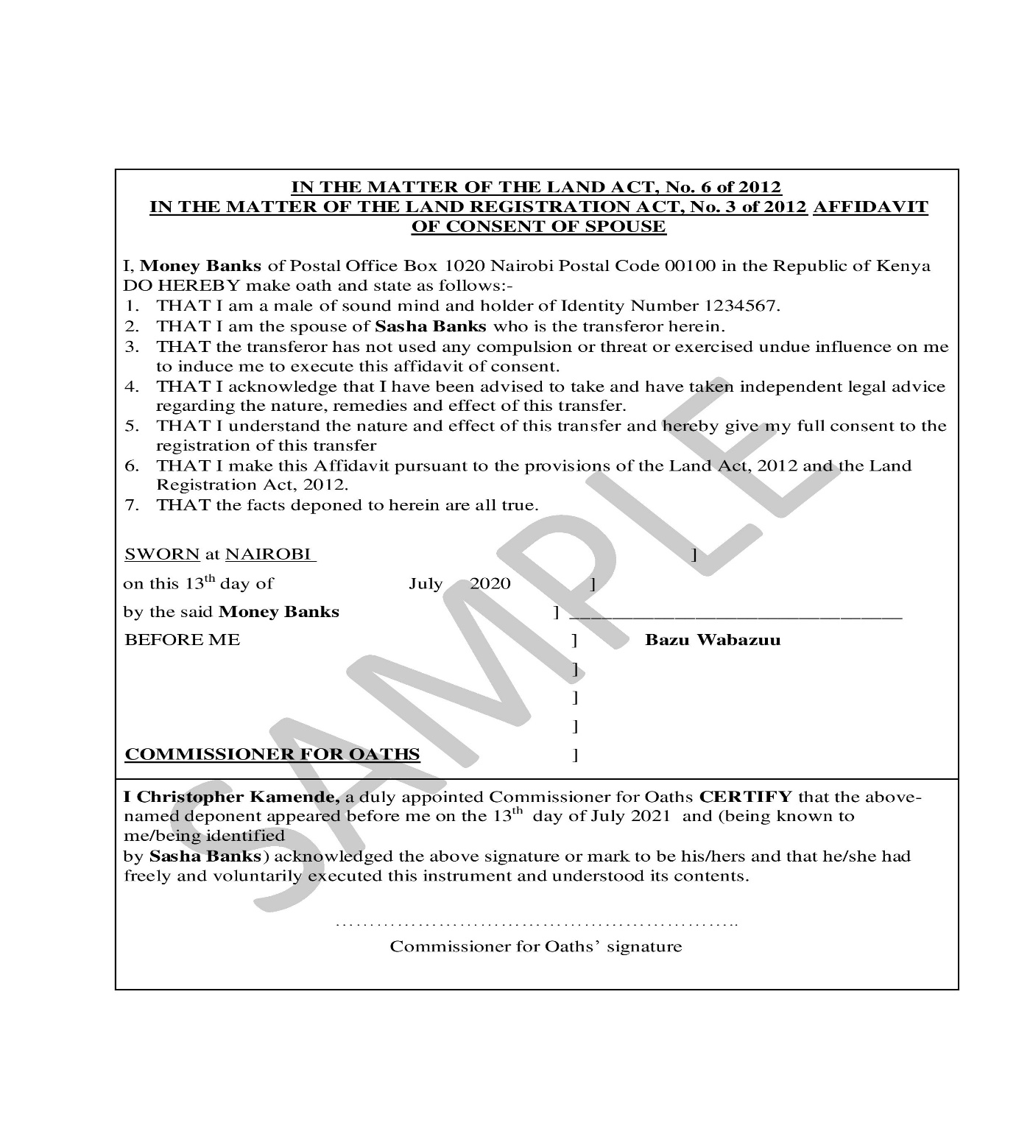

**Agreement 2**

The following are the completion documents which will be required to complete the agreement for sale of a portion of land entered into between JOHN OTIENO ONYANGO (VENDOR) and PETER KAMAU MWAURA (PURCHASER):

* Original Title deed
* Original and valid land rent clearance certificates
* Original and valid land rates clearance certificates
* Coloured passport sized photographs of the Vendor
* Certified copy of the Vendor’s identity card and Tax PIN certificate

**Original Title deed**

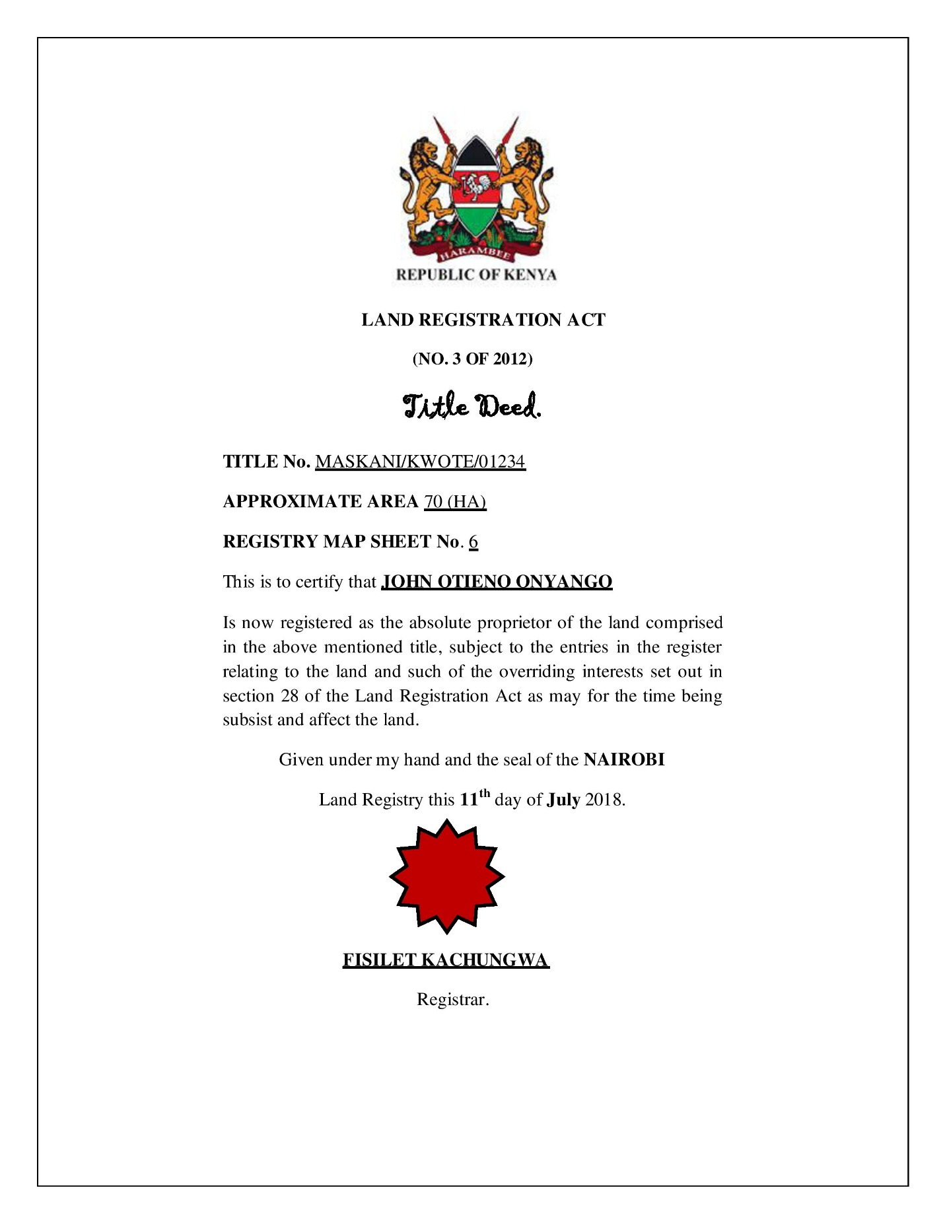

**Rent Clearance Certificates**

A Land Rent Clearance Certificate applies specifically to areas where the land is leasehold. Section 39(1) of the Land Registration Act provides that the registrar shall not register any instrument that seeks to create any interest in land if land rents for that particular property owe. A Land Rent Clearance Certificate is the evidence of payment of such rents and it is issued by the Registrar.

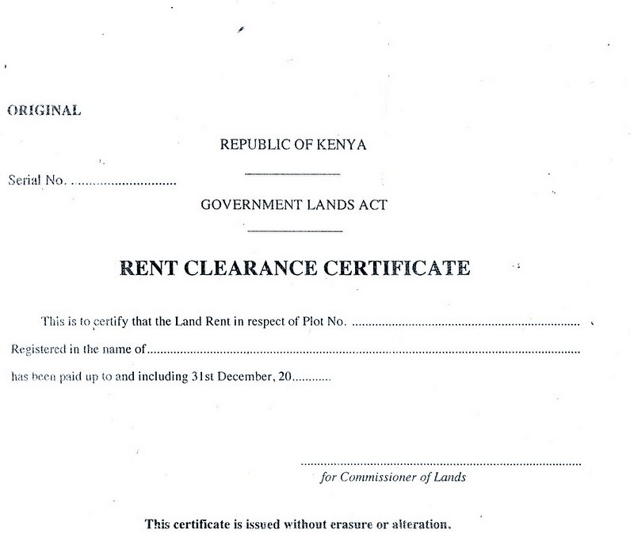

JOHN OTIENO ONYANGO

MASKANI/KWOTE/01234

**Rates Clearance Certificates**

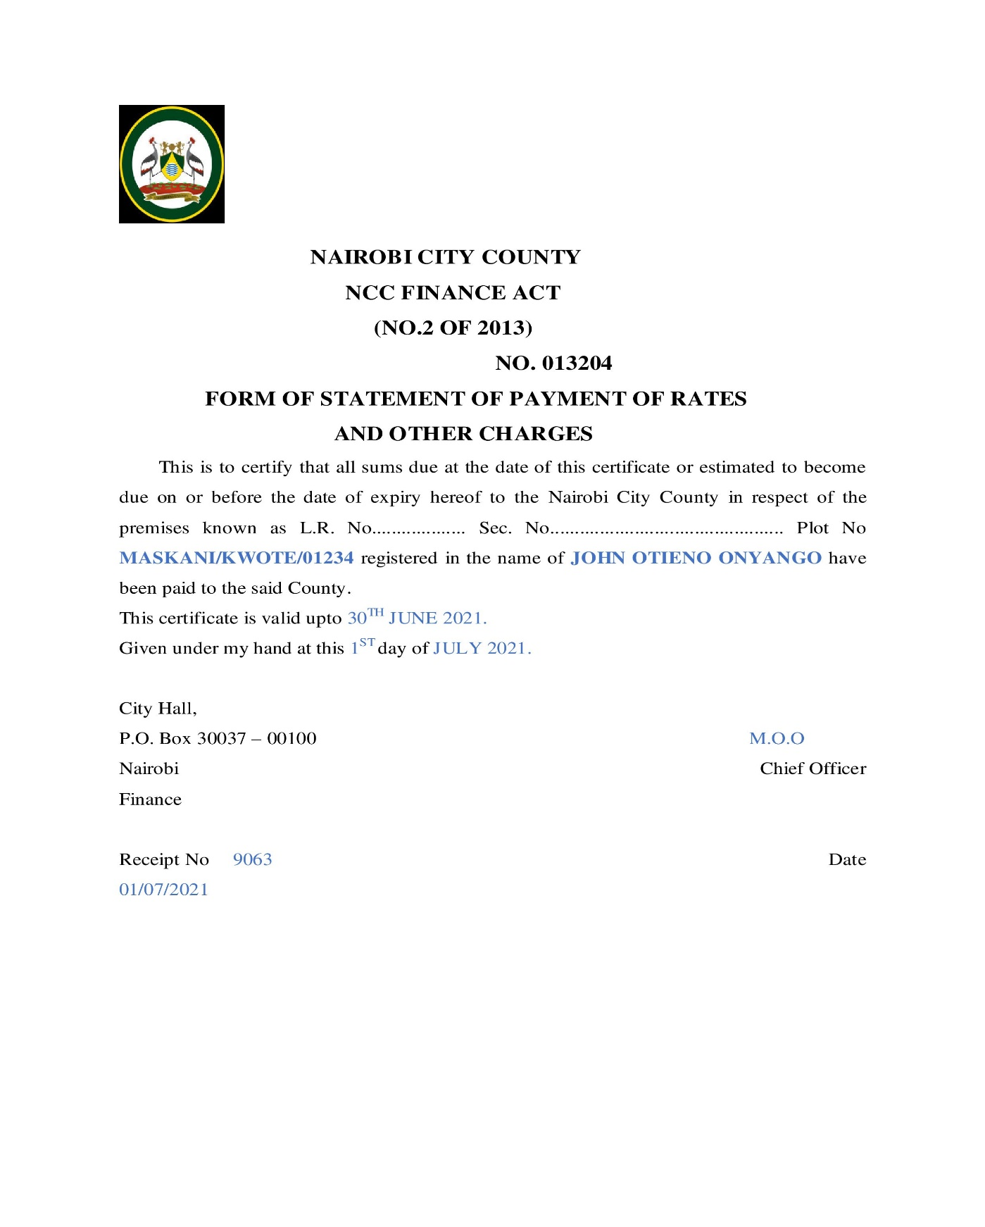

**Coloured Passport Sized Photographs of the Vendor**



**Copy of the Vendor’s Identity Card**



**JOHN OTIENO ONYANGO**

**Copy of the Vendor’s Tax PIN certificate**

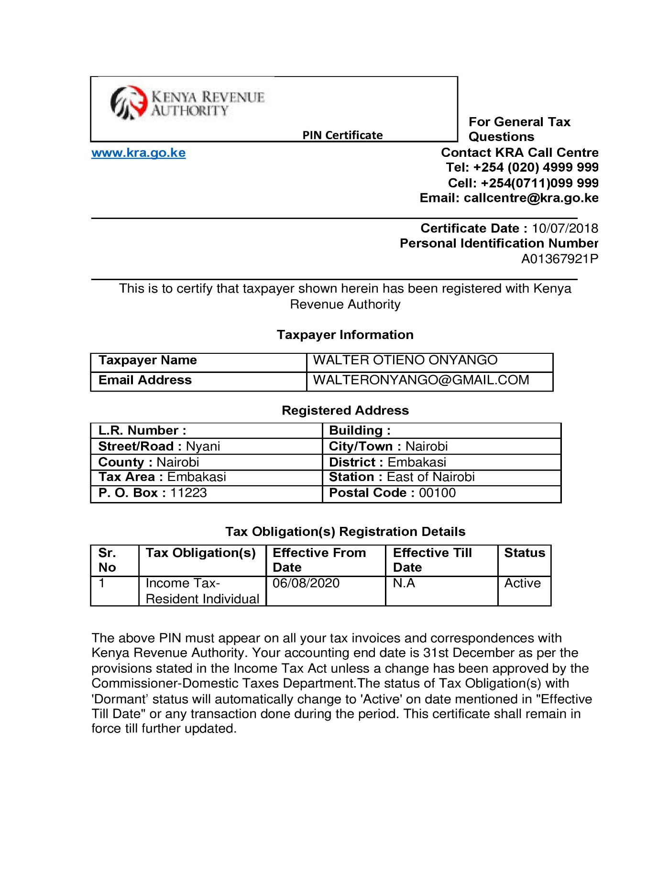

**Agreement 3**

The following are the completion documents which will be required to complete the agreement for sale of one (1) two - bedroomed apartment entered into between KAMASKI LIMITED (VENDOR) AND GEORGE JOHN KINOO & GLADYS JANE KINOO (PURCHASER)

* The original Lease in respect of the Apartment duly registered in favour of the Purchaser;
* The original Share Certificate in respect of One (1) share in the Management Company;
* Certified copy of the Certificate of Incorporation of the Management Company;
* Original receipts evidencing payment of Stamp Duty in respect of the Lease;
* Duly completed Valuation Report for Stamp Duty;
* Certified copy of the booking form in respect of the Lease;
* Certified copy of the architect’s Certificate of Practical Completion;
* A copy of the NEMA License.
* Certificate of Occupancy

**Original Lease Certificate**

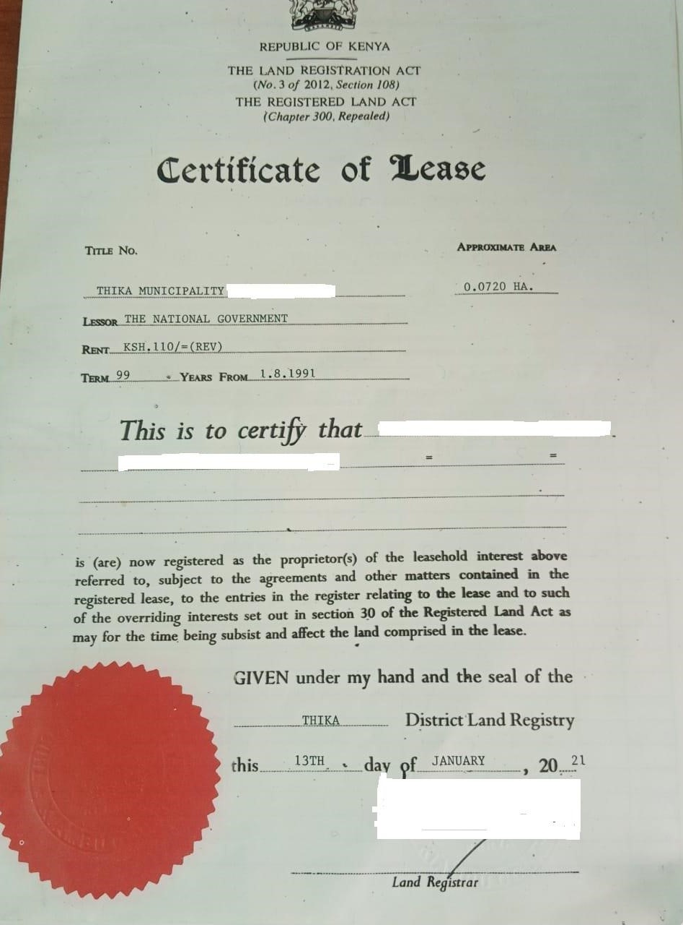

**GEORGE JOHN KINOO & GLADYS JANE KINOO**

**KAMASKI LIMITED**

**Original Share Certificate**

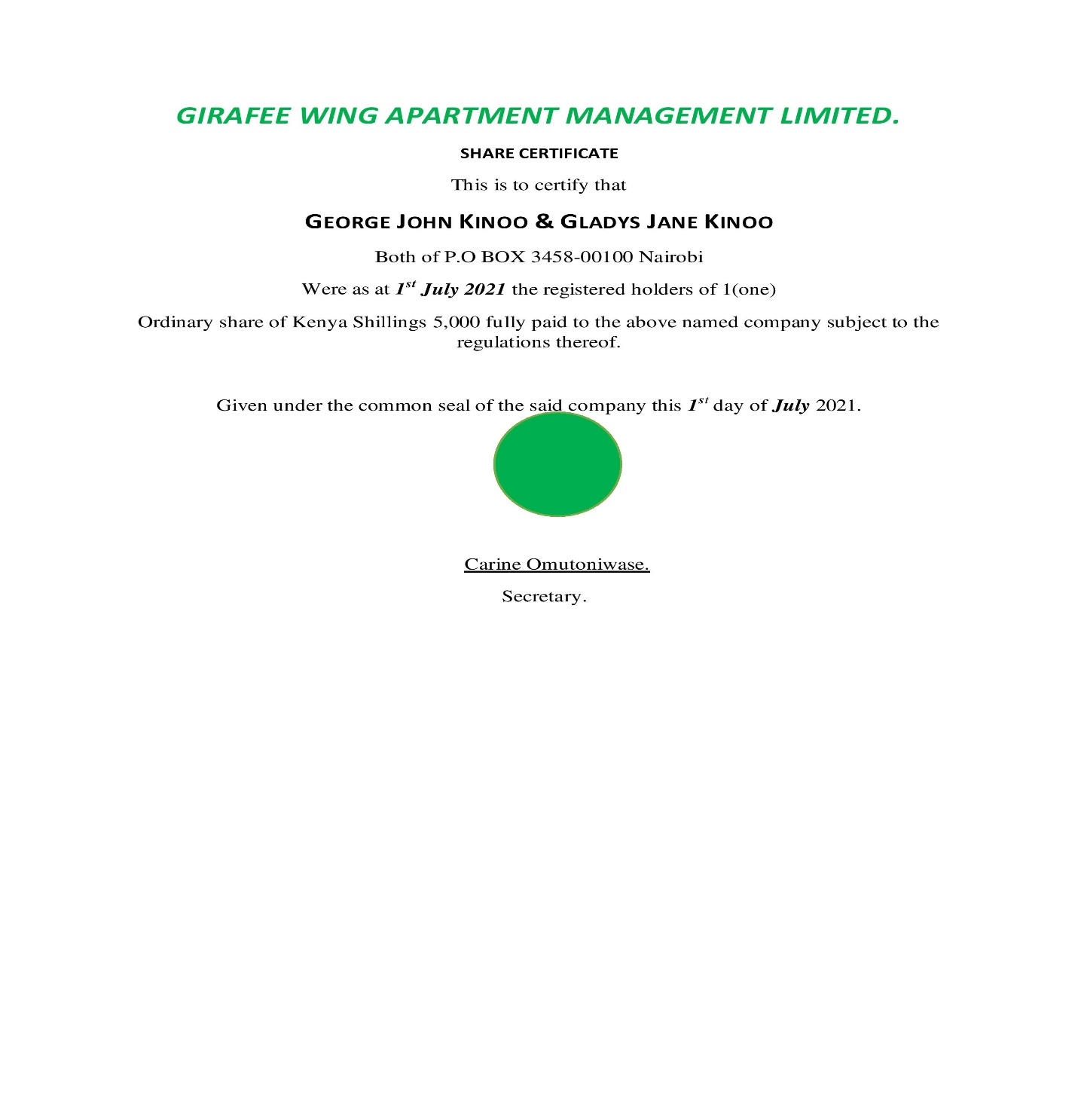

**Certificate of Incorporation of the Management Company**

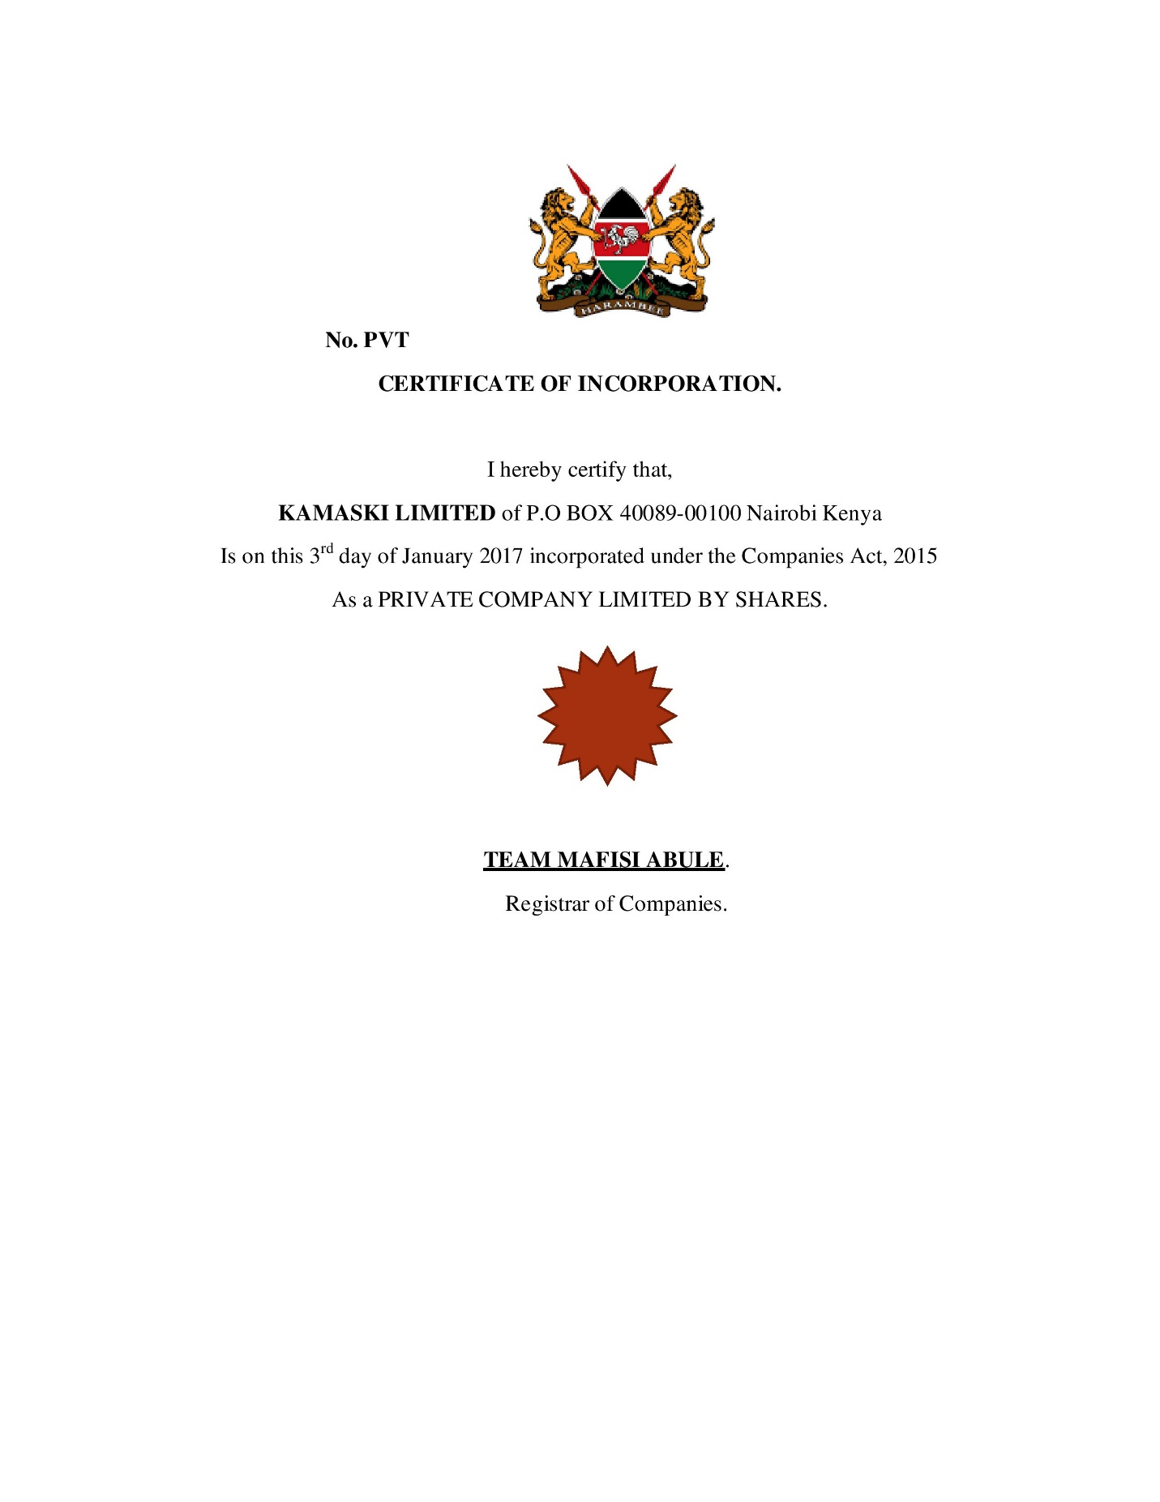

**Certified Copy of Architect’s certificate of Practical completion**

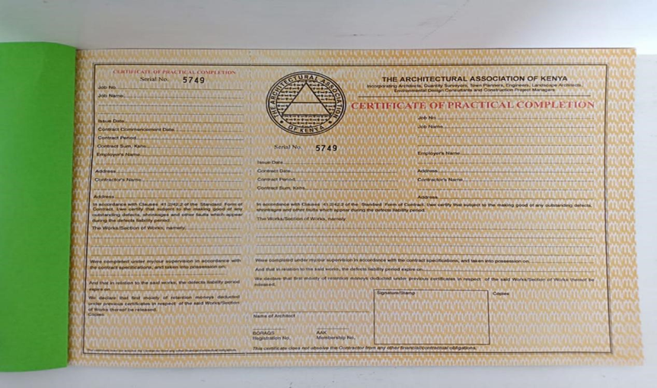

**Copy of the NEMA License**

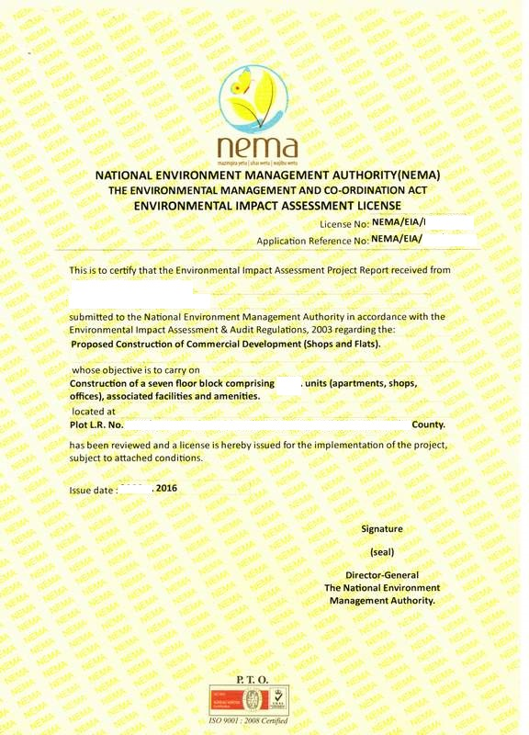

**KAMASKI LIMITED**

**DAGORETTI/ RIRUTA /0002**

**Valuation Report for Stamp Duty**

Valuation is provided for under the **Stamp Duty (Valuation of Immovable Property Regulations**), **2020.**

Under the regulations, immovable is defined to include land, whether covered by water or not, any estate, right, intestate or easement on or over any land, and things attached to the earth or permanently fastened to anything attached to the earth.

A valuation can be conducted by a Government Valuer or a private Valuer appointed by the Chief Government Valuer. Under regulation 4, a transferee of an immovable property is required to apply, in writing to the Chief Government Valuer for valuation of the property. The CGV may then value the property himself, or appoint a Government Valuer or any other registered Private Valuer to conduct a valuation.

Upon valuation, the Valuer shall submit the valuation report to the CGV within 21 days for approval. A valuation report shall be valid for a period of 12 months from the date of approval.

Regulation 5 provides for the contents that shall be contained in a valuation report for it to be valid. Such include; the names and addresses of the registered owners of the property, location of the property, land reference or the title deed number, tenure of the property, the valuation methodology, the basis for the valuation, the market value of the property, date of valuation and the seal or sign of the valuer.

When conducting a valuation, a Valuer may consider the following factors;

1. The size of the land
2. The location of the property
3. Proximity to certain amenities e.g. schools, shopping complexes, access road, availability of electricity, posh restaurants etc.
4. Key Architectural design or style
5. Current condition of the property
6. The topography of the land upon which the property is sitting.
7. The land block layout
8. The size of the commercial property
9. Property features like bathrooms, bedrooms and kitchenette
10. Possibility of developments or renovations.

**VALUERS INCORPORATED COMPANY LIMITED.**

**P.O BOX 10724-00400**

**NAIROBI.**

**COMESA HOUSE 4TH FLOOR, LEFT WING.**

**VALUATION REPORT.**

**Instructed By:** KAMASKI LIMITED.

**Address:** P.O BOX 400089-00100 NAIROBI.

**Prepared For:** George John Kinoo

Gladys Jane Kinoo.

**Purpose for Valuation:** Payment of stamp duty

**Description of Property:** 1 one bedroom apartment No. 5B

**Critical Assumptions:** Nothing noteworthy.

**Significant Risks:** No issues

**Inspection/ Valuation date:** 3rd July 2021.

**Date of Report:** 5th July 2021.

**Valuation Approaches/ Methodology:** Net rate analysis and direct comparison

**Valuation:** Ksh. 6, 500, 000/=

**Prepared By:** Valuers Incorporated Company Limited.

Registration number: 300

**Booking Form**

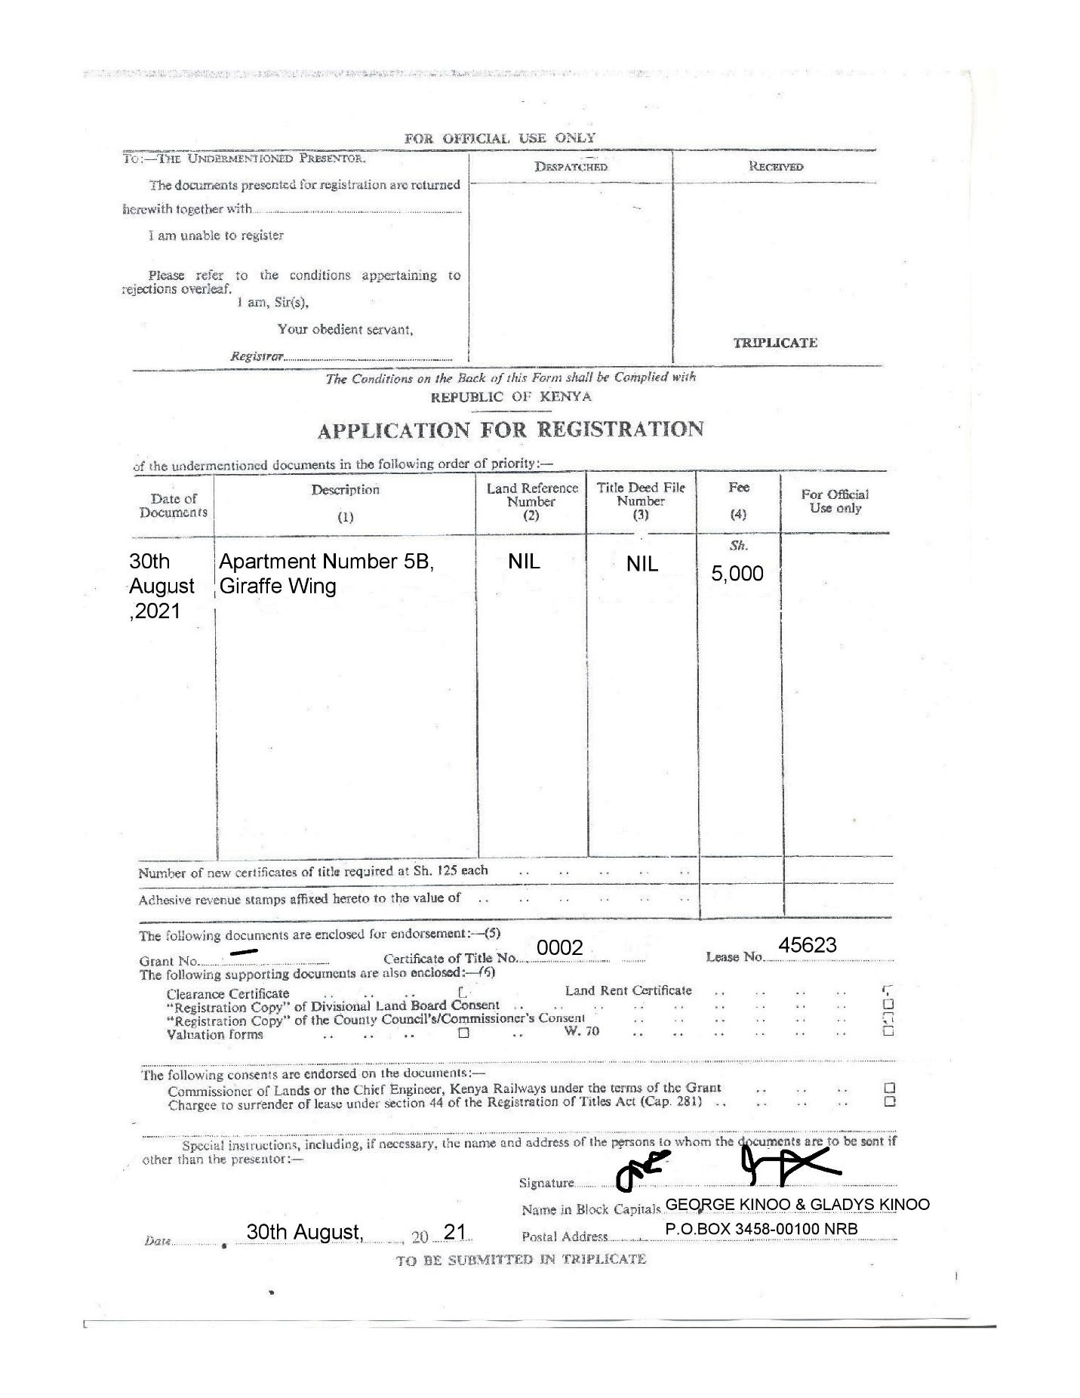

**Stamp Duty Receipt**

Stamp duty is basically revenue raised by the Government by requiring stamps sold by the Government to be affixed to designated documents

* Section 5 The Stamp Duty Act (Cap 480) demands that every instrument relating to property in Kenya be stamped.
* Section 6.The duty is to be paid within 30 days of execution of the document or of its receipt if it is executed outside Kenya
* Section 113 Failure to pay duty is equivalent to evasion of tax and is a criminal offence.
* Section 46 of the LRA no document is acceptable for registration if the stamp duty required to be paid has not been duly paid and documents properly stamped.

Duty on conveyancing instrument is paid on the ad valorem value (proportionate to the value) at the statutory rate.

Transfers – 4% for properties situate within cities municipalities

2% of the value for properties outside municipalities/cities

Long term Leases or subleases are deemed to be Transfers and fetch duty as if they were Transfers.

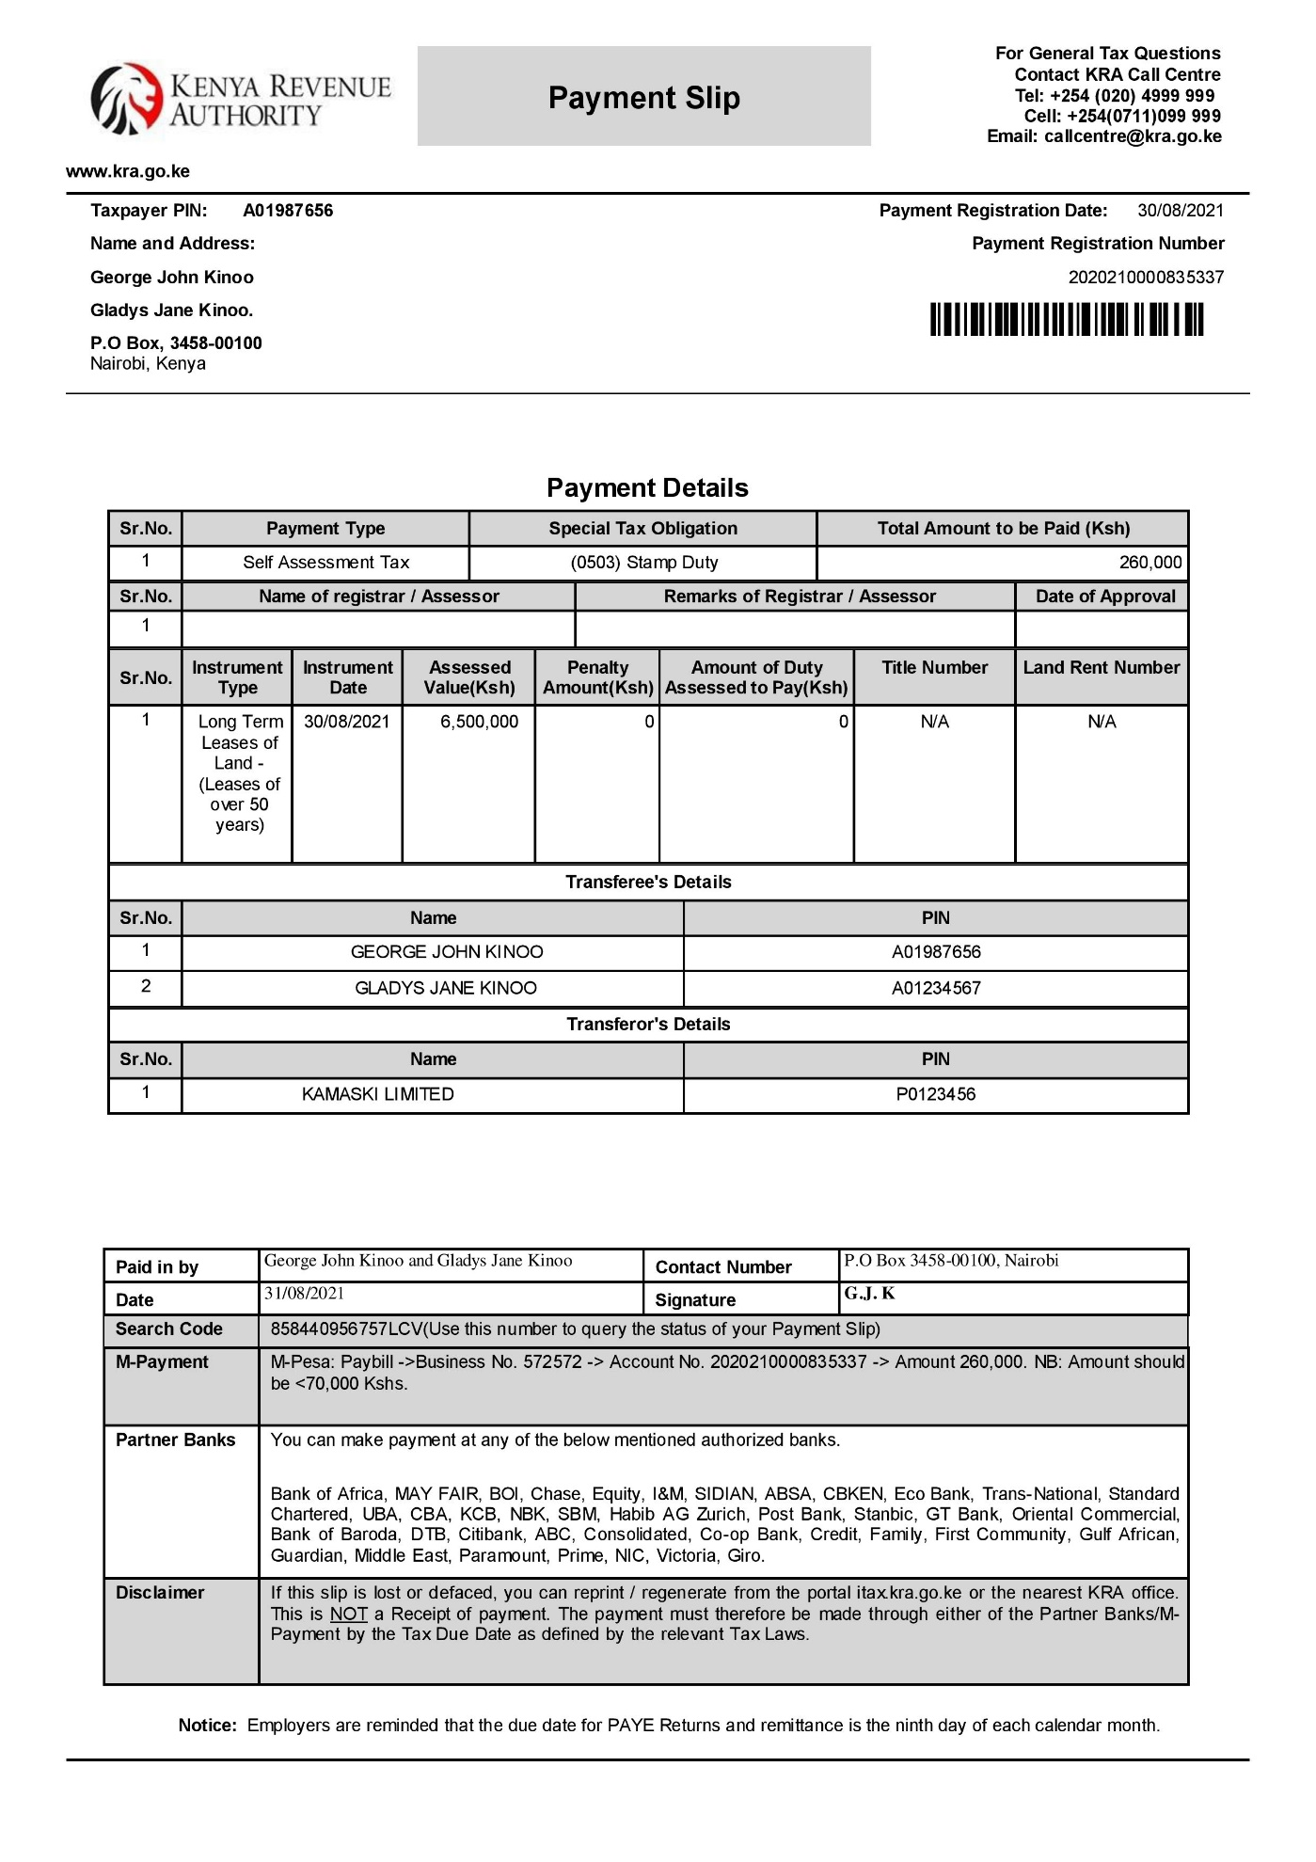

**Certificate of Occupancy**

A Certificate of Occupancy is a document issued by a local government agency or building department certifying a building's compliance with applicable building codes and other laws, and indicating it to be in a condition suitable for occupancy.

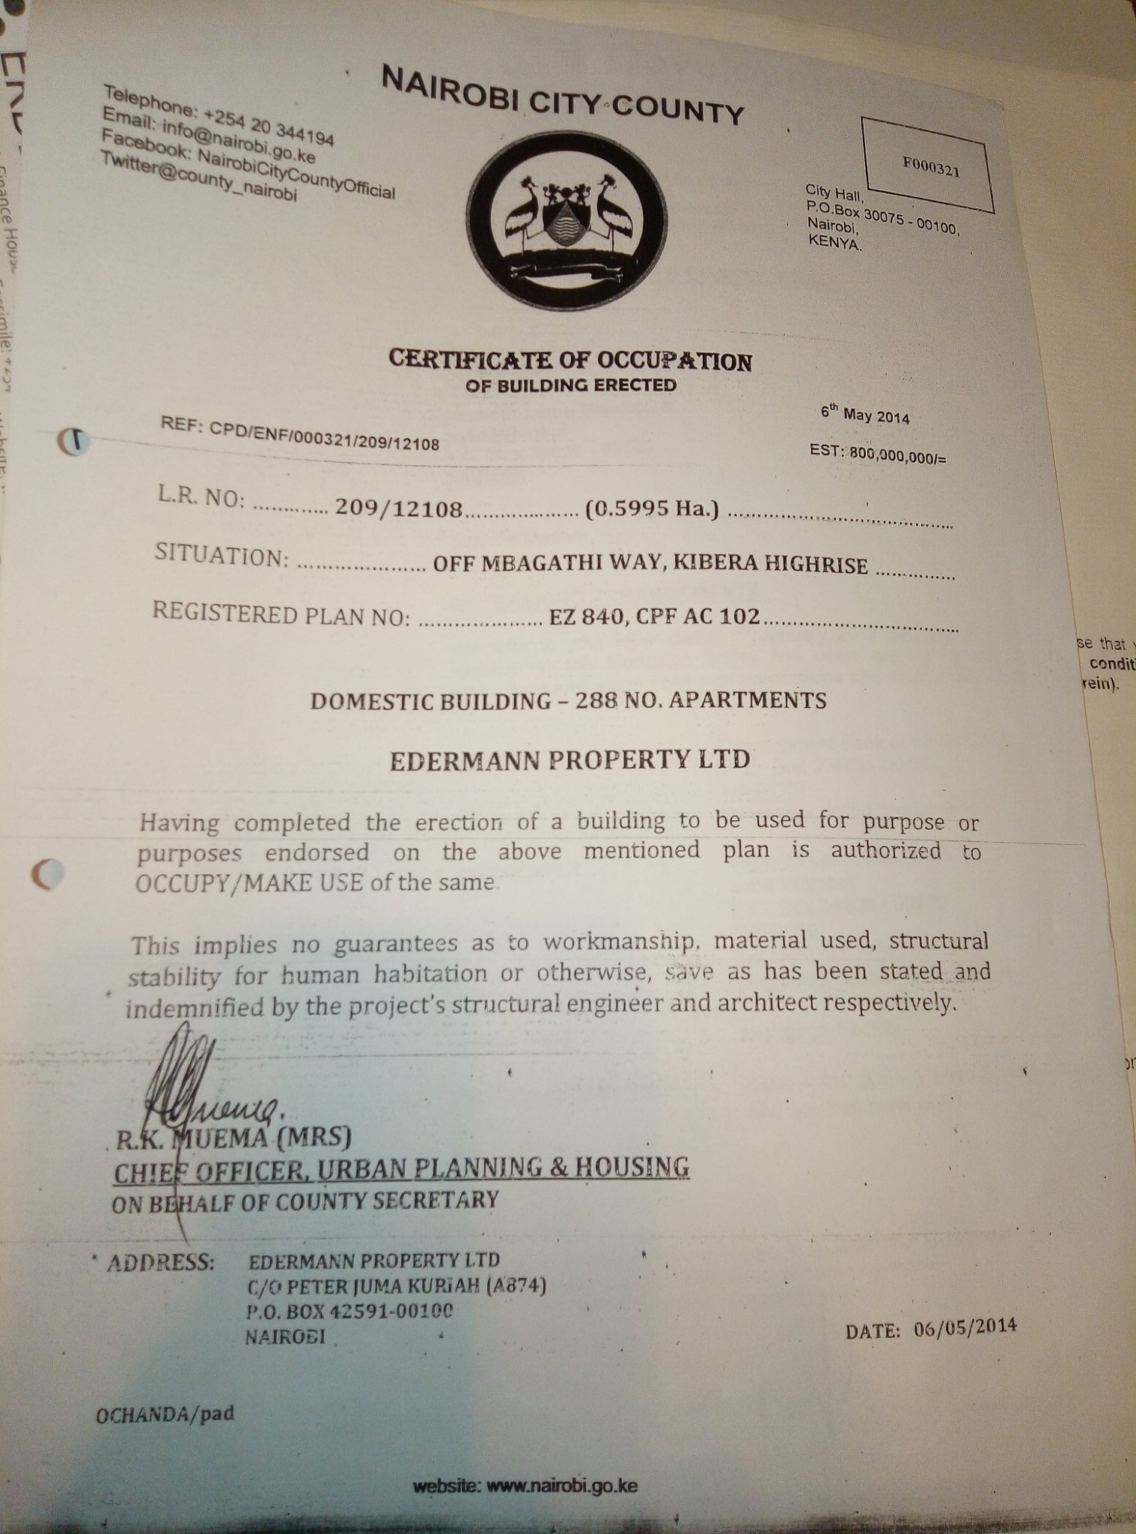

**KAMASKI LIMITED**

**APARTMENT NUMBER 5B (GIRAFFE WING)**

**DAGORETTI/ RIRUTA /0002**